THE 1140A CORPORATION
a Massachusetts non-profit presenting company
FOUNDING PARTNER
Sole Sponsorship Invitation
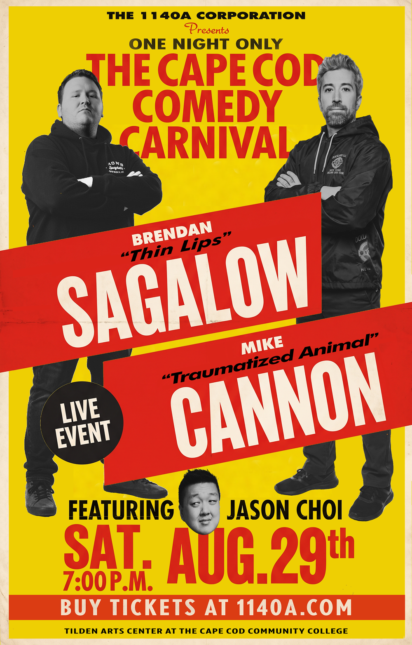
THE CAPE COD COMEDY CARNIVAL
Saturday, 29 August 2026 · Tilden Arts Center at Cape Cod Community College

The Invitation
The 1140A Corporation invites a single organisation to become the sole Founding Partner of The Cape Cod Comedy Carnival — a one-night double-feature comedy event bringing two nationally-touring headliners to the Cape at prices Cape Codders can actually afford.
This is not an advertising buy. It is an invitation to plant your name, from the very first event, at the root of something built to recur — the way a handful of enduring institutions have become inseparable from the events they founded and sustained. What Ralph Lauren is to the polo at the Hamptons, a Founding Partner is to this: not a logo rented for a season, but a name woven into the story from year one.
We are a non-profit. Your participation is a commercial sponsorship — a gift to the arts and culture of Cape Cod with a long-term plan behind it, not a donation and not a grant. You support something genuine, and you are seen doing so, exclusively.
Why This Matters
A civic gift, not an ad campaign
Tickets are already on sale and the campaign is already in motion. A Founding Partner is not buying this single event’s advertising — they are joining a recurring Cape Cod institution at its founding, and being known as the organisation that made affordable, professional comedy possible on the Cape. That association compounds every year it continues.
The long game
This event is the first of a planned series. The corporation intends to present comedy — and, in time, other arts and culture programming — on the Cape on an ongoing basis. A Founding Partner is positioned to grow with it: the same name, event after event, year after year, tied to a body of work the community comes to rely on.
Advertising presence (included, but not the point)
Sole-sponsor visibility is real and it is yours alone — your name and logo on event materials as the single sponsoring organisation, with no competing brand present. We are candid that the campaign is already live, so this is a founding association rather than a launch-window media buy. The value is the partnership; the visibility comes with it.

What the Founding Partner Receives
A single organisation — twelve guests — sole recognition. The following is exclusive; no second sponsor is offered.
▪ Sole sponsor status
You are the only sponsoring organisation. Your name and logo appear on event materials as the sole partner. No competing brand shares the event’s public presence.
▪ A private meet-and-greet with the headliners
Twelve guests, on a bucolic private Cape Cod property, before the show — a relaxed gathering with the comedians in their warm off-stage personas, an open bar, and a spread of presentable summer hors d’oeuvres. This is the honey of the partnership, and it is genuinely enjoyable.
▪ Twelve premium reserved (Orchestra) seats
Your guests are seated in the Orchestra — the reserved VIP section — for the show itself.
▪ A founding association that recurs
First right to continue as Founding Partner of future events in the series.
The Investment
$9,750
sole Founding Partner · twelve guests · one price
One figure, one decision. There is no tiered menu and no negotiation of presence — the Founding Partner owns the whole of it. We have kept the number deliberately approachable because this is a civic partnership, not a media spend.

The Setting
The Founding Partner’s guests are hosted on a private Cape Cod property — open lawns, weathered cottages, a barn, and picnic tables under the summer sky. It is unhurried, pleasant, and quintessentially Cape Cod: the kind of place a party feels like an afternoon, not an appointment.
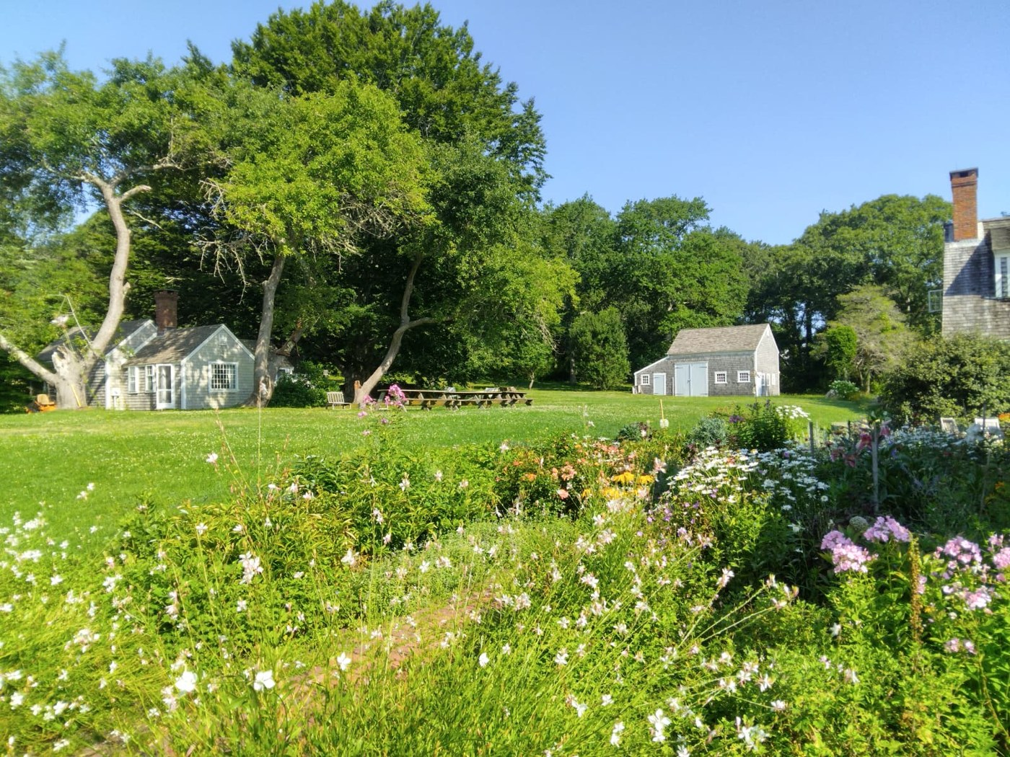
The private property — July 2026.
Here, before the show, your guests meet the headliners over an open bar and a spread of summer hors d’oeuvres — a warm, informal half-hour that turns a night out into an experience your guests remember and attribute to you.

The Talent
Two nationally touring headliners — both Comedy Cellar regulars — and a rising featured act. Official biographies and photographs follow.
BRENDAN SAGALOW “Thin Lips”
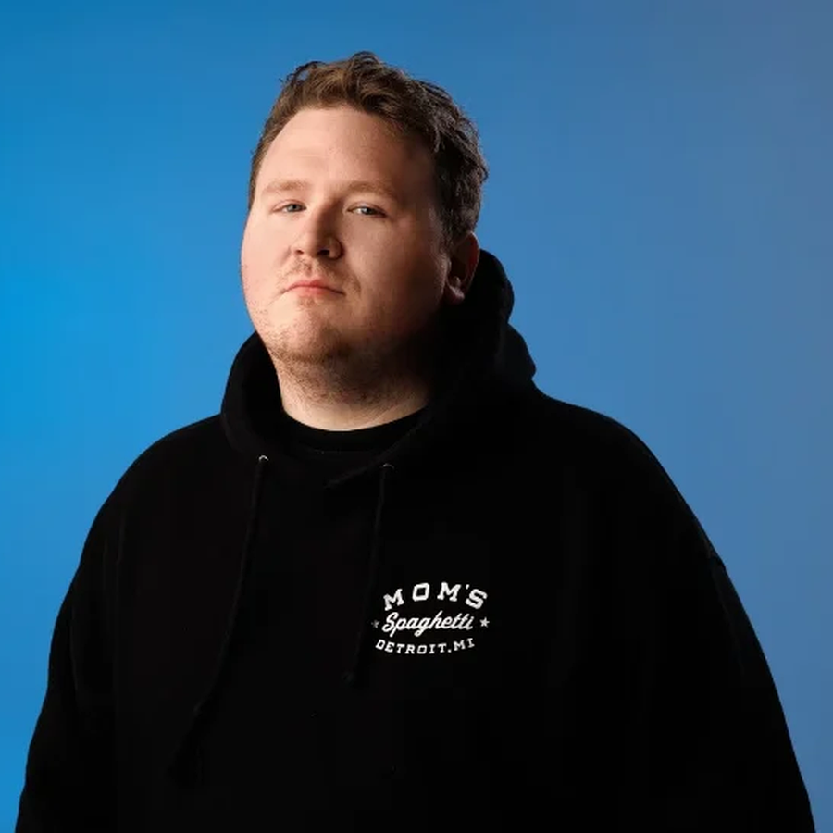 | Brendan Sagalow is a New York City-based stand-up comedian whose confident social observation and cutting self-deprecation have taken him across the country and into leading New York clubs, including the Comedy Cellar. A 2022 Just For Laughs New Face, he released his debut full-hour special, Thin Lips, independently on YouTube in August 2024. His credits include ViceTV’s Tumbleweeds, MTV’s Joking Off, and regular appearances on major comedy podcasts and SiriusXM programmes.

MIKE CANNON “Traumatized Animal”
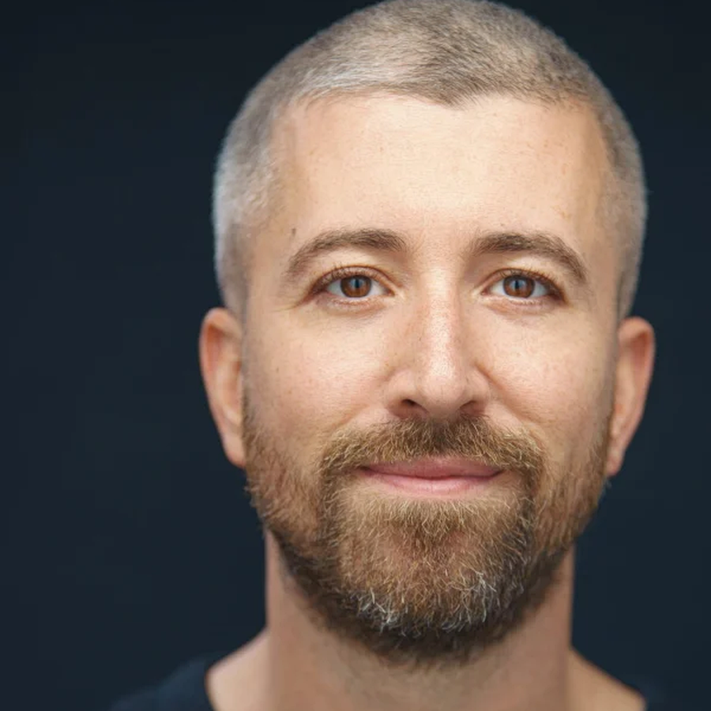 | Mike Cannon is a New York City-based comedian, podcaster, writer and actor, and a regular at leading clubs including the Comedy Cellar. He has headlined nationally — including a sold-out performance at Gramercy Theatre — and released his latest special, Traumatized Animal, in September 2024. His credits include Comedy Central, MTV2, TruTV, Barstool Sports and ViceTV; his sharp storytelling, self-aware writing and crowd work make him a commanding live headliner.

JASON CHOI featured
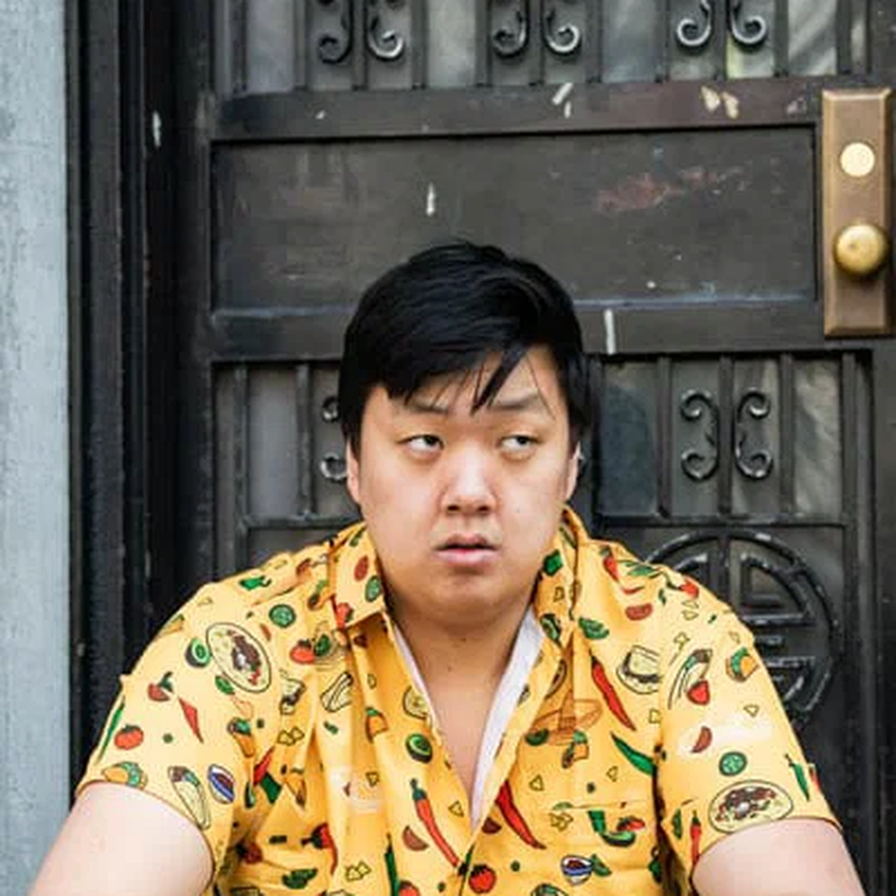 | Jason Choi is a New York-based comedian, writer and actor. He appeared in the 2025 New York Comedy Festival’s New York’s Funniest Stand-Ups showcase, was a finalist at the Boston Comedy Festival and the New York Comedy Club Fall Invitational, and appeared on CBS’s Comics Unleashed with Byron Allen in May 2026. He has opened for Ronny Chieng, Mike Cannon and Gary Gulman, and performs regularly at New York comedy clubs.

The 1140A Corporation
The 1140A Corporation is a Massachusetts non-profit presenting company, founded to bring professional performing arts to Cape Cod at prices the community can afford. The Cape Cod Comedy Carnival is its inaugural production — the first of a planned, recurring series of comedy and cultural events.
The corporation’s premise is simple: quality entertainment, presented with care, priced for Cape Codders, and built to last. It owns and produces its own events; a Founding Partner is not sponsoring a one-off, but joining an organisation at the beginning of what it intends to become.
The event is presented at the Tilden Arts Center at Cape Cod Community College, a professional Cape venue — a fitting home for a company that means to be part of the Cape’s cultural life for years to come.

Become the Founding Partner.
Max Makowski · The 1140A Corporation
116 New Boston Road, Dennis, MA 02638 · 1140A.com

